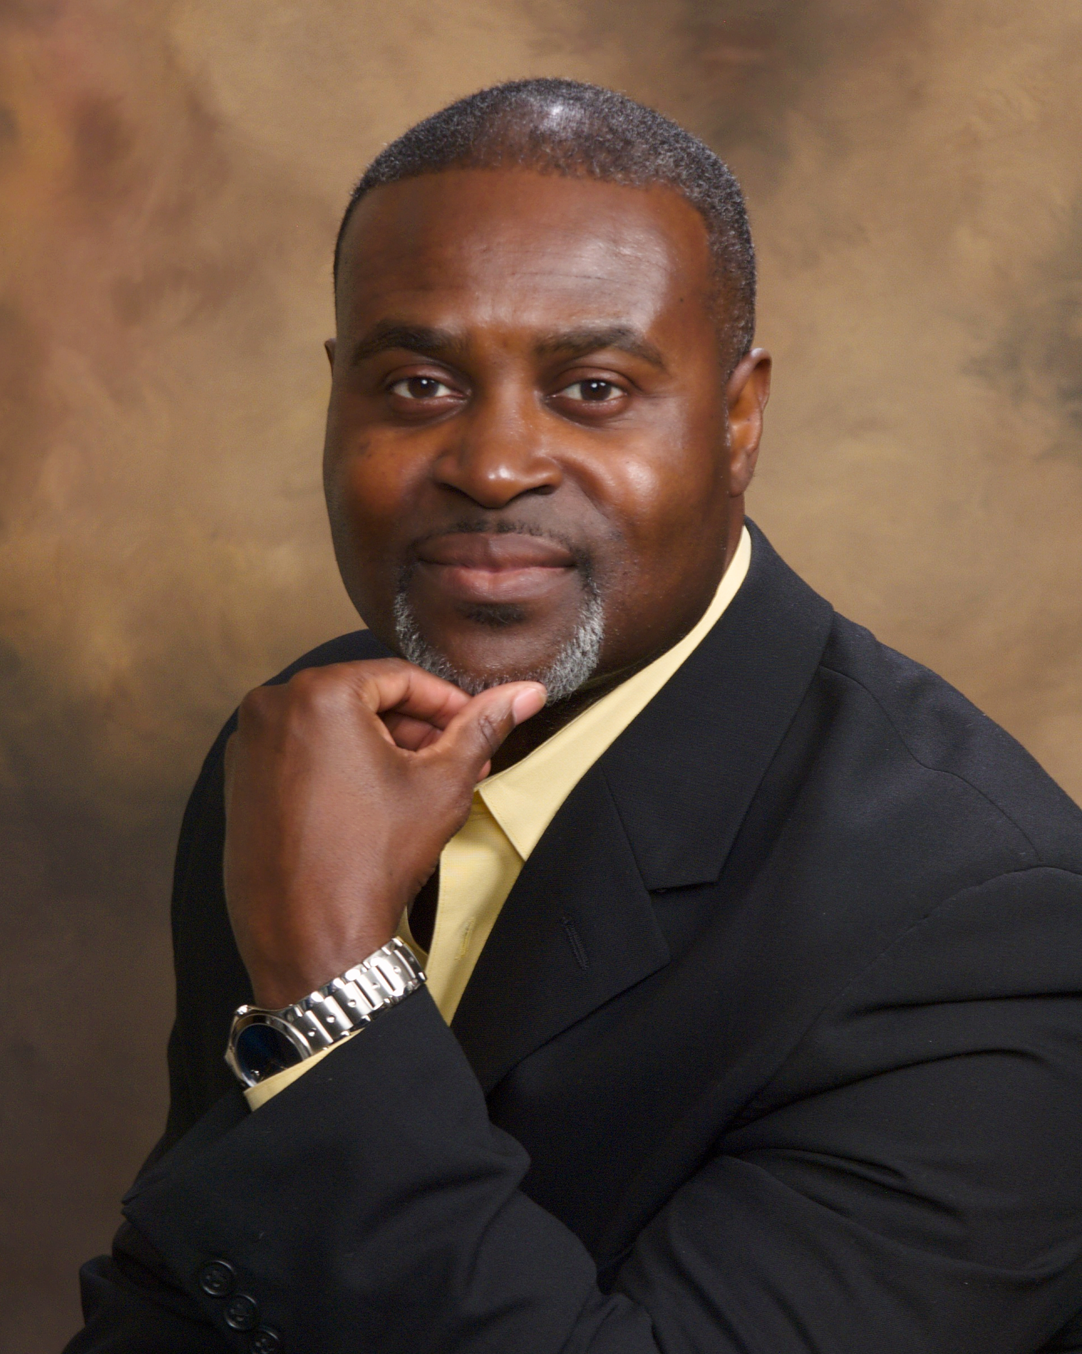

Mr. Eric Harmon is a United States Air Force, Retired, Command Chief Master Sergeant. He is a native of Guyana, South America. Queens, New York, is where his family has lived since moving to the United States. He graduated from Aviation High School, Long Island City, New York. He entered the Air Force in August 1982 and retired after 27 plus years of active duty service in July 2010.

Prior to retirement, Eric served as the 72d Air Base Wing and Oklahoma City Air Logistics Center Command Chief Master Sergeant. He served as the principle advisor to the 72d Air Base Wing and Oklahoma City Air Logistics Center Commanders on matters concerning effective utilization, training and development, readiness and concerns affecting 843 enlisted members responsible for providing base and direct operational support for associate units within six different commands.

Throughout his career, he served as Commandant and Instructor of Airman Leadership School, First Sergeant for a humanitarian mission, Superintendent of numerous organizations, and coach and mentor to many airman, officers and civilians. All jobs he has held entailed taking care of people and ensuring they had what they needed to succeed, not only while serving in the military, but also throughout life.

Today, Eric specializes in motivational speaking, mentoring, and mindset coaching. With more than 27 years of experience in motivating and inspiring others to be the best they can be in all their endeavors, Eric has developed four principles, which he uses to assist individuals and organization in their desire to transform their lives or create a harmonious working environment. He accomplishes this through helping people recognize their purpose through self-awareness. He is CEO and President of P4 Principles, LLC.

Eric’s ability to assist individuals to realize their value and purpose in life and how to succeed at making their dreams a reality are noted throughout his Air Force career. No matter where he was stationed, overseas or stateside, his known mentoring and coaching skills had leaders and followers seeking his advice and services. He is still actively serving as a mentor to many airman sent to him from current base leadership and friends.

Eric has been married for 27 years and has two daughters. He and his wife Shirley reside in Choctaw, OK.

**EDUCATION**

2005 - Bachelor of Science Workforce Education and Development, Southern Illinois University, Carbondale, IL

2008 – Air Force Enterprise Management Seminar, University of North Carolina, Chapel Hill, NC

2008 – Air Force Executive Leadership Course, University of Tennessee, Seattle, WA

#### **AWARDS**

Meritorious Service Medal with four oak leaf clusters

Air Force Commendation Medal with two oak leaf clusters

Air Force Achievement Medal with three oak leaf clusters

Korea Defense Service Medal

**HONORS**

1985 - Outstanding Young Man of America

1986 - Health Service’s Management Inspection Outstanding Performer Award

1987 – Pacific Air Forces Noncommissioned Officer Leadership School Drill Master Award

1987 - 1991 - Health Service’s Management Inspection Outstanding Performer Award

1995 - 89th Support Group Noncommissioned Officer of the Year

1996 - 89th Airlift Wing Noncommissioned Officer of the Year

1997 - 86th Medical Group Senior Noncommissioned Officer of the Year

1997 - European Command Public Health Senior Noncommissioned Officer of the Year

1999 - 86th Medical Group Senior Noncommissioned Officer of the Year

2001 - 60th Aerospace Medicine Squadron Senior Noncommissioned Officer of the Year

2003 - Air Mobility Command Public Health Senior Noncommissioned Officer of the Year